Name : Saurabh Sanjay Jadhav

Topic : Terraform workspaces.

Assignment no. : 18

Workspace : It isolates the resources or terraform states created based on various workspaces defined.

1. Check the list of workspaces.

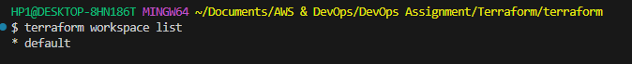

1. Create new workspace and switch to it.

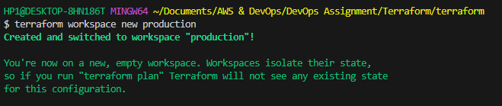

1. Show currently using workspace.



1. Initialize the terraform in new workspace.

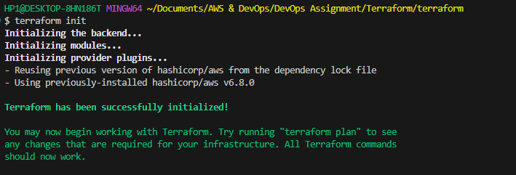

Hence new directory is created in S3 bucket env:/

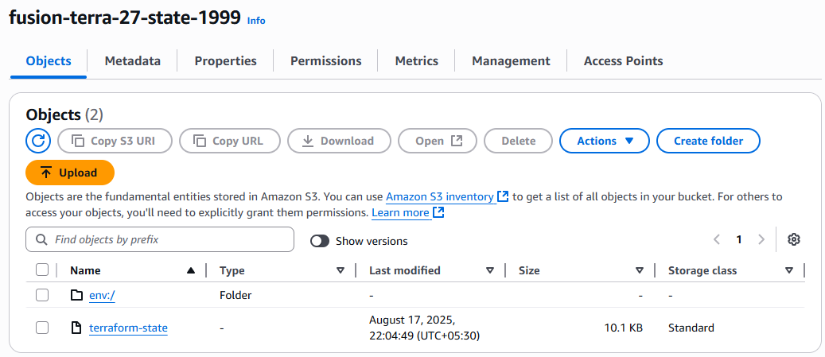

1. Provide value of –var-file using workspace command.

Terraform plan –var-file=$(terraform workspace show).tfvars

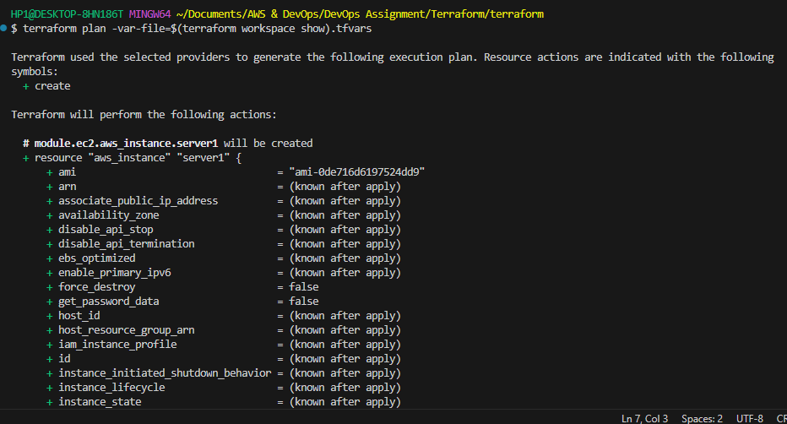

Terraform apply –var-file=$(terraform workspace show).tfvars

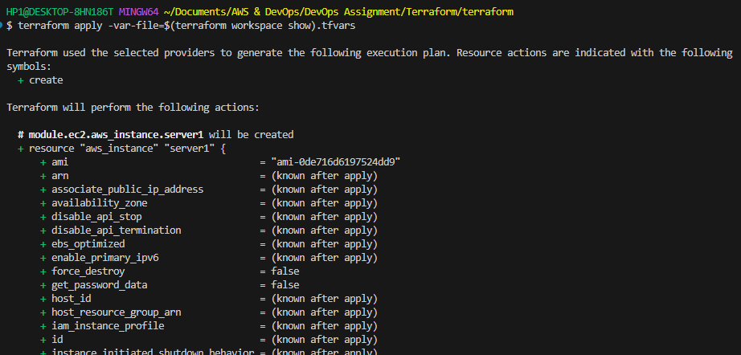

Hence successfully we have created the new vpc and ec2 instance with production workspace.

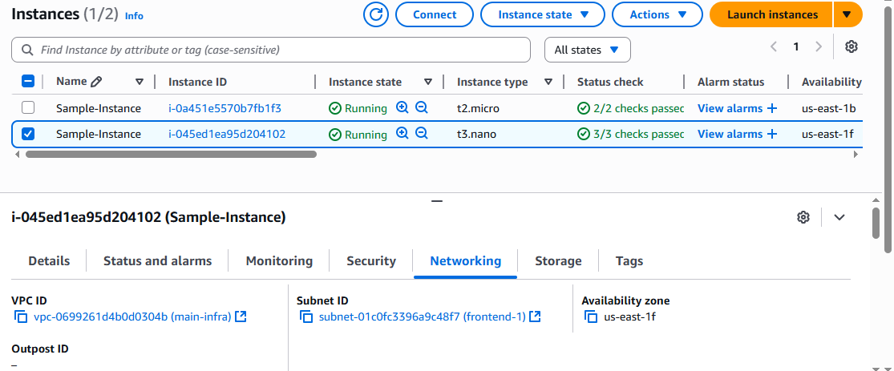

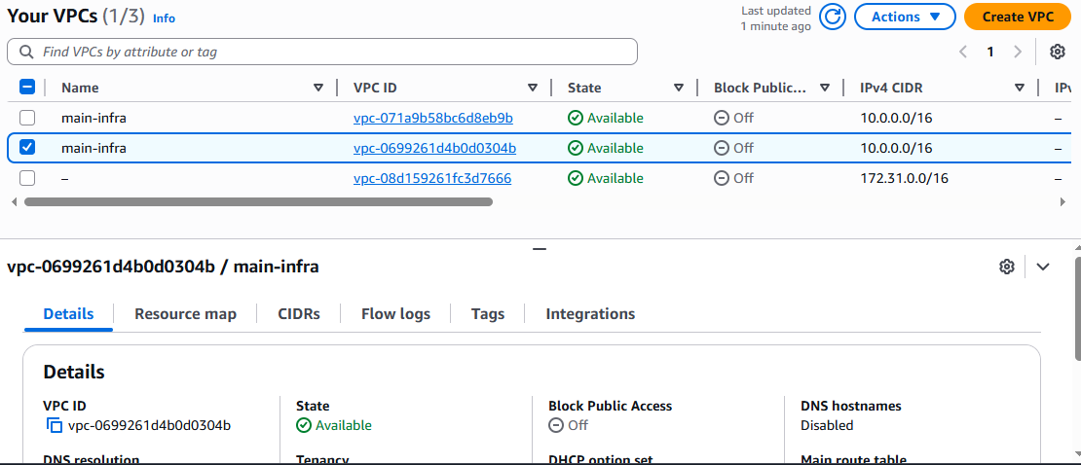

**Creating multiple resources.**

/terraform/modules/ec2/main.tf

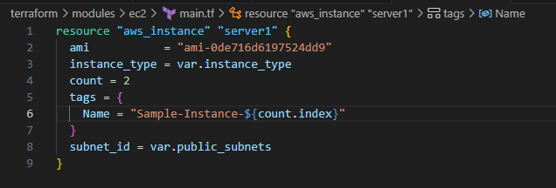

>> terraform init

>> terraform apply –var-file=staging.tfvars

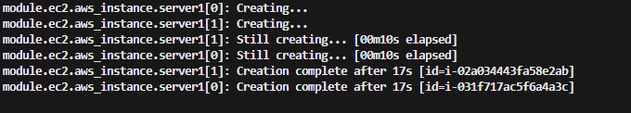

Successfully created 2 instance simultaineously.

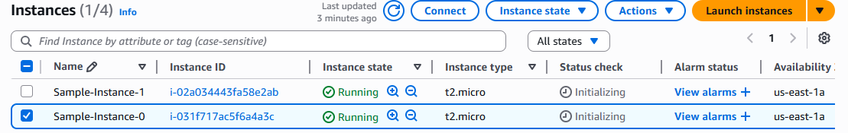

**Creating multiple instance with different configurations**

/terraform/modules/ec2/main.tf

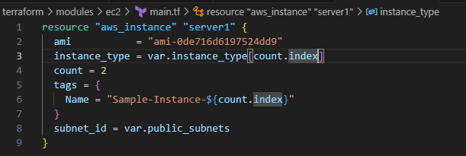

/terraform/modules/ec2/variable.tf

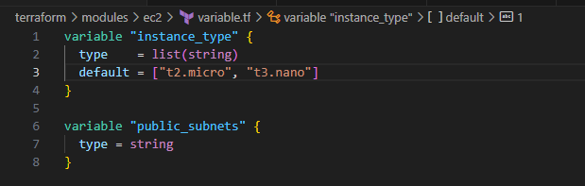

Hence successfully we have created 2 instances with instance types as t2.micro and t3.nano

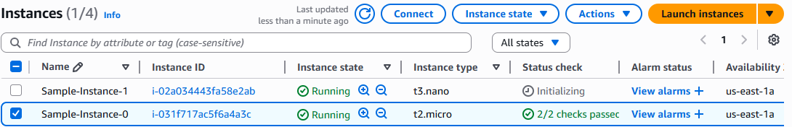

Using # for single line comment

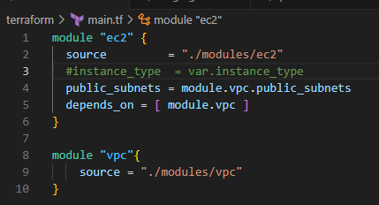

Using /* .. */ for multiple line comment

